http://premiumlayers.net/demo/html/fugiat/

1) HOME PAGE



Prisma Electric Switchgear Ind. – Since 1998 : 20 Years of Experience

-------m------

Prisma Electric Switchgear Industry LLC. was set up in the Emirate of Sharjah in the year 1998, with an earnest effort to deal in a most suitable & efficient way and cope with the growing requirements in the field of Construction, Oil & Gas, Marine and Industrial sector in U.A.E. Prisma is conveniently located in the centre of Sharjah, industrial area # 4, Off Al Qasmia street.

Prisma achieved ISO 9001:2000 quality management system certification as a commitment to deliver superior quality services and products to the ultimate satisfaction of the customers.



|  |  |
| --- | --- |
| **Who we are**  LVSwitchgear Manufacturer & Trader serving  GCC countries for past 19 Years. | **What we do**  We Manufacture LV Switchgear – Power, Control, Automation Panels for all the Commercial & Industrial Sector |
| **Our Great Team**  Our Engineers & Technicians are highly experienced in Switchgear Manufacturing, Testing & Commissioning. | **Our Achievements**  Our LV Switchgear panels are Fully Type tested as per IEC 61439 from 400A,800A, 1600A, 2500A, 4000A |

|  |  |
| --- | --- |
|  | *Photo as per attached - **PHOTO # 01** |



**Our Setup**

-------m------

Prisma electric’s Office, Factory setup & organizational structure is developed professionally to work in desirable atmosphere which results in Zero error in All our projects.



|  |  |
| --- | --- |
| **ePLAN**  Complete Engineering Process is based on ePLAN starts from Design Engineering, Assembly, Supply, Service & maintenance of the Low Voltage Switchgear – Power,Control, Automation panels | **Testing Instruments**  Our Testing Instruments for all our Manufacturing, Testing & Commissioning activites such as HV Test kit, Insulation  Resistance test Kit, Primary injection Test Kit , Earth Leakage tester, Millivolt drop test, etc., |
| **ERP :**  **Enterprise resource planning Software**  Starts from Sales, Estimation, Design, Procurement, Production , QAQC Departements are Centralised with our ERP system. | **ISO**  Prisma Electric achived ISO 9001:2008 Quality management System Certified for the “Marketing, Sales, Engineering, Assembly, Testing, Commissioning & After Sales Service of Low voltage Switchgear & Control Panels |
| **24/7 Sales & Technical Support**  Our Sales, Design, Quality Control Engineers will be Online 24x7 to support our Clients Issues & troubleshoot all the technical Problems. | **Type Test as per IEC 61439**  Our LV Switchgear panels are Fully Type tested as per IEC 61439 from 400A,800A, 1600A, 2500A, 4000A |

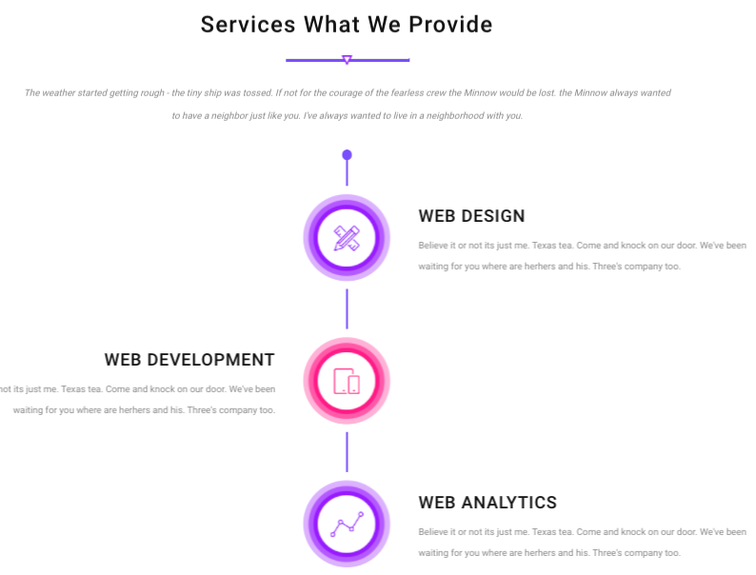

Prisma Electric – Services What We Provide

-------m------

Prisma Electric Switchgear Industry LLC. Is a Manufacturer of Low voltage Switchgear Panels in Power, Control, Automation Panels.

We specialize in Generators Synch. , Motor control, Process instrumentation and control solutions.

|  |
| --- |
| **Manufacturing : LV Switchgear Power, Control, Automation Panels**  We Manufacture LV Panels Upto 10,000A, Synchorinising Panels, Motor Control Centre, PLC,SCADA Automation Panels, etc., |
| **Trading : LV Switchgear Components & Accessories**  ACB, MCCB, Contactor, O/L Relay,  Indication Lamps, Sel Switches, Fuse Bases, Push buttons, ELS/ELR, PFR, Timers, Digital Programmable timers etc, Aux. Relays ,Voltage transformers, Busbar Supports, Enclosures etc., |
| **Maintenance : LV Switchgear Power, Control, Automation Panels**  We do Complete Maintenance & Retrofit Job in LV Panels, Distribution Boards, Synchorinising Panels, Motor Control Centre, PLC,SCADA Automation Panels, etc., |



Prisma Electric – Why Choose Us?

-------m------

Prisma Electric Switchgear Industry LLC., - One Of the Reputed & Experience LV Switchgear Manufacturer & Trader In the Middle East with 20 Years of Experience & Given Our Services to more than 1,000 Customers & Approved by Major Consultants & Water,Electricity Authorities.

(1) Unique Products

We Use only Tested & Certified products for our LV Switchgear Panels, We get Minimum 2 Years Warranty from the date of Materials purchase, Our Standard Warranty term is 18 Months from the date of Delivery.

(2) Experienced Team

Prisma Electric’s presence is more than 20 years in the Middle East, Our Engineers & Technicians have more than 10 Years of Experience in the Same LV Swtchgear Manfuacturing Sector.

(3) Greater Services

With a well-proven portfolio of impressive projects completed outstandingly in the past decades, Prisma Electric is committed to deliver projects with the highest client satisfaction at the right time at right standard.

Approvals

-------m------



Put Heading as “Approvals”

Add these Logos as per the attached…